WORKSHEET 3.1

Student Name:Ravi Shankar Singh UID: 21BCS11619

Branch: CSE Section/Group: 808-B

Semester: 4th Date of Performance:

Subject Name: Programming in Python Lab Subject Code: 21CSP-259

**Aim:**

**Program to implement various kinds of searching and sorting algorithms**

1. **Write a Python program to implement linear search.**

**Source Code:**

def linear_search(arr, target):

for i in range(len(arr)):

if arr[i] == target:

return i

return -1

numbers = [4, 2, 9, 7, 5, 1, 6, 3, 8]

target_number = 5

result = linear_search(numbers, target_number)

if result != -1:

print(f"Element {target_number} found at index {result}")

else:

print("Element not found")

**OUTPUT:**

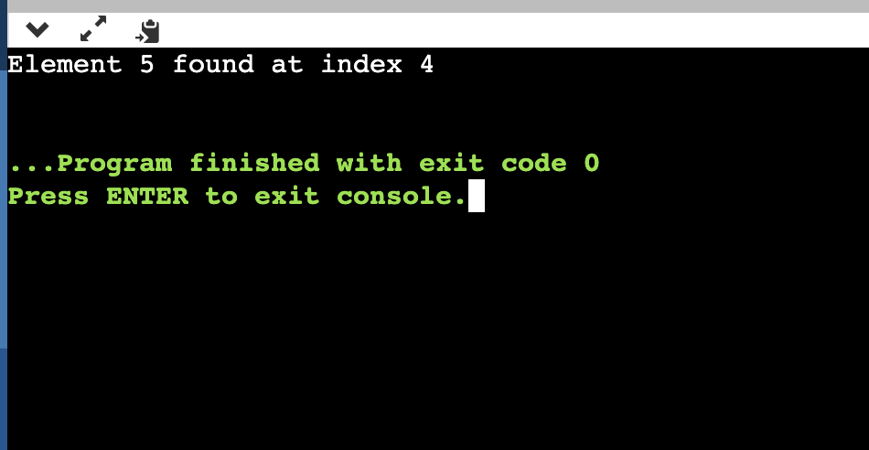

1. **Write a Python program to implement bubble sort.**

**Source Code:**

def bubble_sort(arr):

n = len(arr)

for i in range(n - 1):

for j in range(0, n - i - 1):

if arr[j] > arr[j + 1]:

arr[j], arr[j + 1] = arr[j + 1], arr[j]

numbers = [64, 34, 25, 12, 22, 11, 90]

print("Original array:", numbers)

bubble_sort(numbers)

print("Sorted array:", numbers)

# **OUTPUT:**

# 

1. **Write a Python program to implement binary search without recursion.**

**Source Code:**

def binary_search(arr, target):

left = 0

right = len(arr) - 1

while left <= right:

mid = (left + right) // 2

if arr[mid] == target:

return mid

elif arr[mid] < target:

left = mid + 1

else:

right = mid - 1

return -1

numbers = [1, 2, 3, 4, 5, 6, 7, 8, 9]

target_number = 5

result = binary_search(numbers, target_number)

if result != -1:

print(f"Element {target_number} found at index {result}")

else:

print("Element not found")

**OUTPUT:**

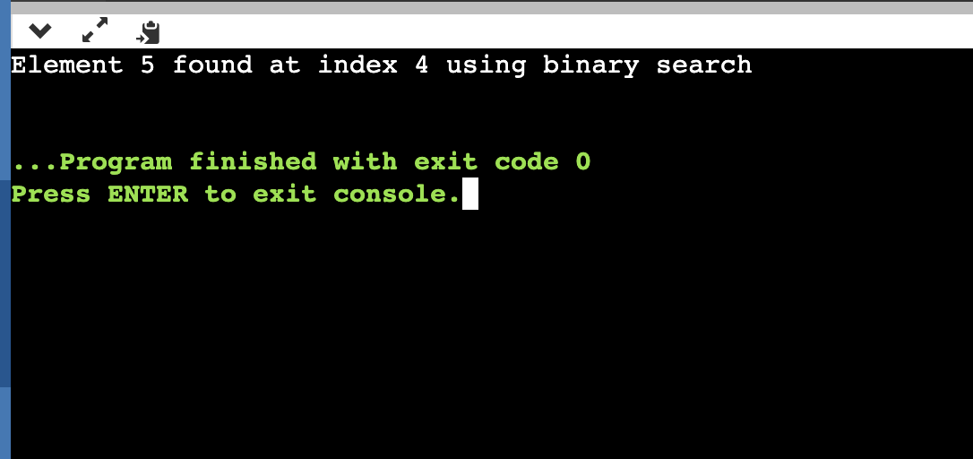

1. **Write a Python program to implement selection sort.**

**Source Code:**

def selection_sort(arr):

n = len(arr)

for i in range(n - 1):

min_index = i

for j in range(i + 1, n):

if arr[j] < arr[min_index]:

min_index = j

arr[i], arr[min_index] = arr[min_index], arr[i]

numbers = [64, 25, 12, 22, 11]

print("Original array:", numbers)

selection_sort(numbers)

print("Sorted array after selection:", numbers)

**OUTPUT:**

